Name:__________________
VALENCE ELECTRONS
The electrons in the outermost shell of an atom are called valence electrons.
Here is an electron dot diagram of a lithium atom. Circle its ONE valence electron.

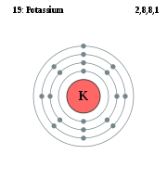
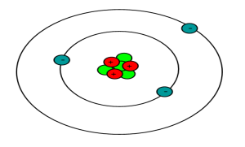
Look at the electron dot diagram to the right:
How many electrons in the innermost shell?
How many electrons are there in the next 2 shells?
How many valence electrons does the potassium atom have?

The innermost shell of every atom has a maximum of ____ electrons. Every other shell has a maximum of ____ electrons. Each shell must be full before a new one forms on top of it.

Note the electron configuration written above it. This also shows how many electrons are in each shell.

Draw the electron dot diagram and write the electron configuration for Boron with 5 electrons

How many valence electrons does boron have?

Fill in the following table
ELEMENT | DIAGRAM | HOW MANY VALENCE ELECTRONS | Electron configuration
 | 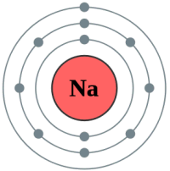
 | 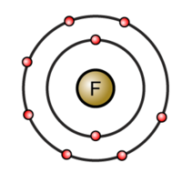
 | 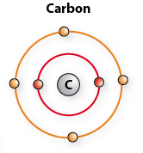
 | 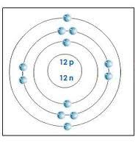

Outermost shell Metals
Atoms always want to have their outermost shell full.
For atoms like potassium it is easy to do this by losing one electron.
Into the space below draw the electron configuration for Beryllium with 9 electrons.

How many valence electrons does beryllium have?

How can beryllium get its outermost shell full?

NOTE. Metals lose electrons to make their outermost shells full. They make positive ions.

Outermost shell Non-Metals
Into the space below draw the electron configuration for oxygen.
O₈¹⁶

How many valence electrons does oxygen have?

How can oxygen get its outermost shell full?

NOTE. Non-Metals gain electrons to make their outermost shells full. They make negative ions.

Valence electrons on the periodic table

The periodic table is arranges so that all the elements with one valence electron are in the first column. All the elements with two electrons are in the second column. All the elements in the seventh column have ______ valence electrons.

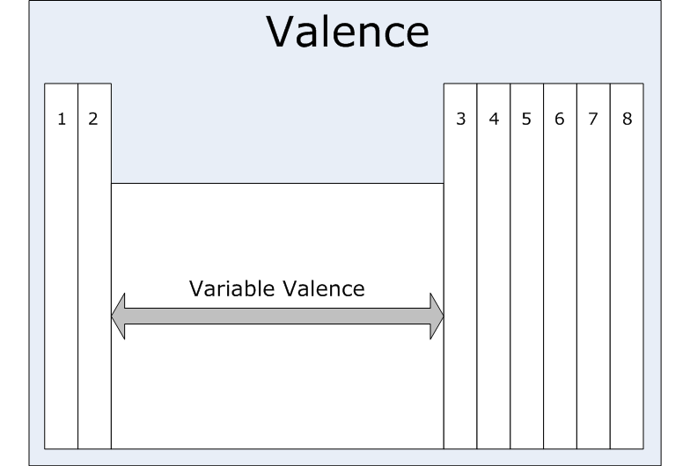

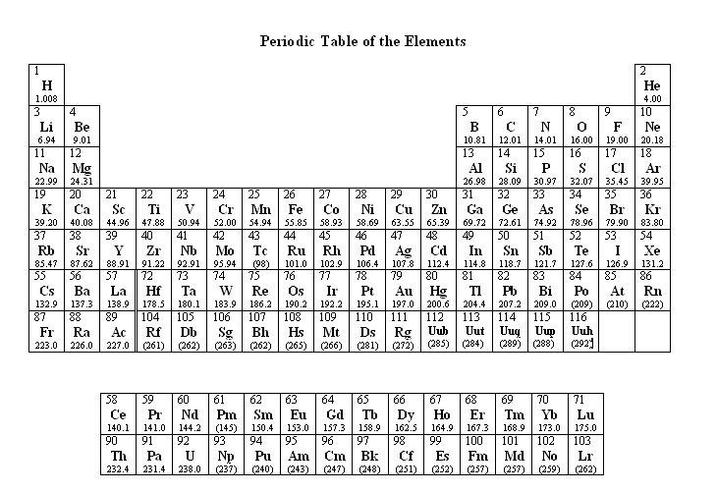
Use what you have learned above and your periodic table to complete the following table.
element | Column of the periodic table | Number of valence electrons | Does it lose or gain electrons | Does it form positive or negative ions | Metal or non-metal
Lithium
Magnesium
Calcium
Chlorine
Carbon
Sodium
Bromine
sulphur
Iodine

Noble Gases
Some elements have all their outer shell filled up. They are very stable and do not loose or gain electrons. They are called the noble or inert gasses.
They are found in eighth column. Find them and list them here.

